Lesson 11

**Black Box test design techniques practice. Pt.2: decision tables, state transition diagrams, use case testing**

1. Which statement about the state transition diagram and the table with test cases is correct?

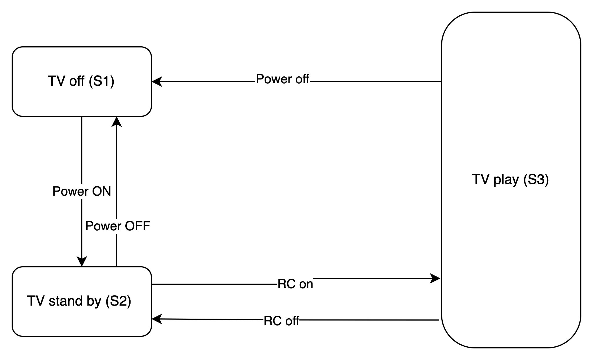

| Test case | 1 | 2 | 3 | 4 | 5 |
| --- | --- | --- | --- | --- | --- |
| Beginning State | S1 | S2 | S2 | S3 | S3 |
| Power | Power on | Power Off | RC on | RC off | Power Off |
| Ending State | S2 | S1 | S3 | S2 | S1 |

A. These test cases cover valid and invalid transitions in the chart.

B. These test cases show all possible valid transitions on the chart. (correct)

C. These test cases cover some valid transitions on the chart.

D. These test cases cover pairs of transitions in the diagram.

2. Employees of the company are issued bonuses if they have worked for more than a

year and have fulfilled the goals set in advance.

These conditions can be presented in a decision table:

| Test |  | T1 | T2 | T3 | T4 |
| --- | --- | --- | --- | --- | --- |
| Condition 1 | Over one year of experience | Yes | No | No | Yes |
| Condition 2 | Is the goal set? | No | No | Yes | Yes |
| Condition 3 | Is the goal achieved? | No | No | Yes | Yes |
| Action | Issue a bonus | No | No | No | Yes |

Which scenario that is likely in real life is omitted in the table?

A. Condition 1 = YES, Condition 2 = NO, Condition 3 = YES, Action = NO

B. Condition 1 = YES, Condition 2 = YES, Condition 3 = NO, Action = YES

C. Condition 1 = NO, Condition 2 = NO, Condition 3 = YES, Action = NO

D. Condition 1 = NO, Condition 2 = YES, Condition 3 = NO, Action = NO (correct)

Level 2

1. Make a state and transition diagram for testing the following video game:

After starting the game, you find yourself in the Castle of Mysteries, in a room with two

corridors — to the right and the left.

If you go to the right, you will get to the dragon. The dragon gives you a riddle. If the

answer is correct — you leave the castle and win. If not, the dragon gives another riddle.

If you answer incorrectly for the second time, the dragon will eat you, and you lose.

If you go to the left, you will get to the witch. The witch gives a riddle. If the answer is

correct, you leave the castle and win. If the answer is wrong, the witch takes you to the

Dragon.

[State and transition diagram](https://app.diagrams.net/#G16iADbuLZuZtXyH0KeTEnf2hjFjAWVfmx#%7B%22pageId%22%3A%22XkKyA4-nwQY60iMoyVMe%22%7D)

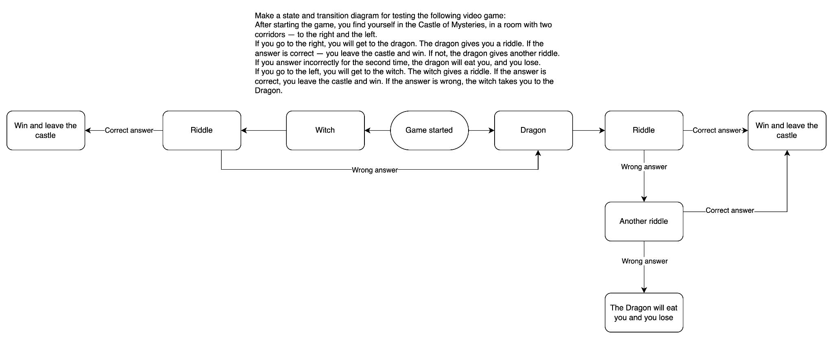

2. How many test cases, according to the diagram, will be enough to test this game?

1. Starting from the "Castle of Mysteries," go to the "Dragon," answer correctly, and "Win."
2. Starting from the "Castle of Mysteries," go to the "Dragon," answer incorrectly the first time, get a second chance, answer correctly, and "Win."
3. Starting from the "Castle of Mysteries," go to the "Dragon," answer incorrectly twice, and "Lose."
4. Starting from the "Castle of Mysteries," go to the "Witch," answer correctly, and "Win."
5. Starting from the "Castle of Mysteries," go to the "Witch," answer incorrectly, get taken

to the "Dragon," answer correctly at the "Dragon," and "Win."

Level 3

We continue to develop a cat photo-sharing app.

a. Write five use cases for how a typical app user would behave.

**I.User Registration and Profile Setup:**

* The user opens the app.
* The user registers for a new account or logs in.
* User sets up their profile with a username and profile picture.

**II. Uploading and Sharing a Cat Photo:**

* The user navigates to the photo upload section.
* User selects a cat photo from their device.
* The user adds a caption and tags to the photo.
* The user chooses whether to share the photo publicly or with specific followers.
* The user uploads the photo.

**III.Browsing Cat Photos:**

* The user explores the app's main feed.
* The user scrolls through a feed of cat photos shared by others.
* User likes and comments on or shares cat photos.
* The user follows other users with interesting cat photos.

**IV . Interacting with Friends and Followers:**

* The user checks notifications for likes and comments on their photos.
* The user responds to comments and likes on their photos.
* The user follows back users who followed them.
* User views the profiles of friends and followers.

**V.Discovering Cat-related Content:**

* The user explores the "Discover" section.
* User views trending cat photos and trending cat-related articles.
* User searches for specific cat breeds or cat-related topics.
* The user reads and comments on cat-related articles.

b. Draw a state transition diagram based on the written user scenarios and make a

decision table for one of the options.

State transition diagram for the cat photo-sharing app based on the written user scenarios:

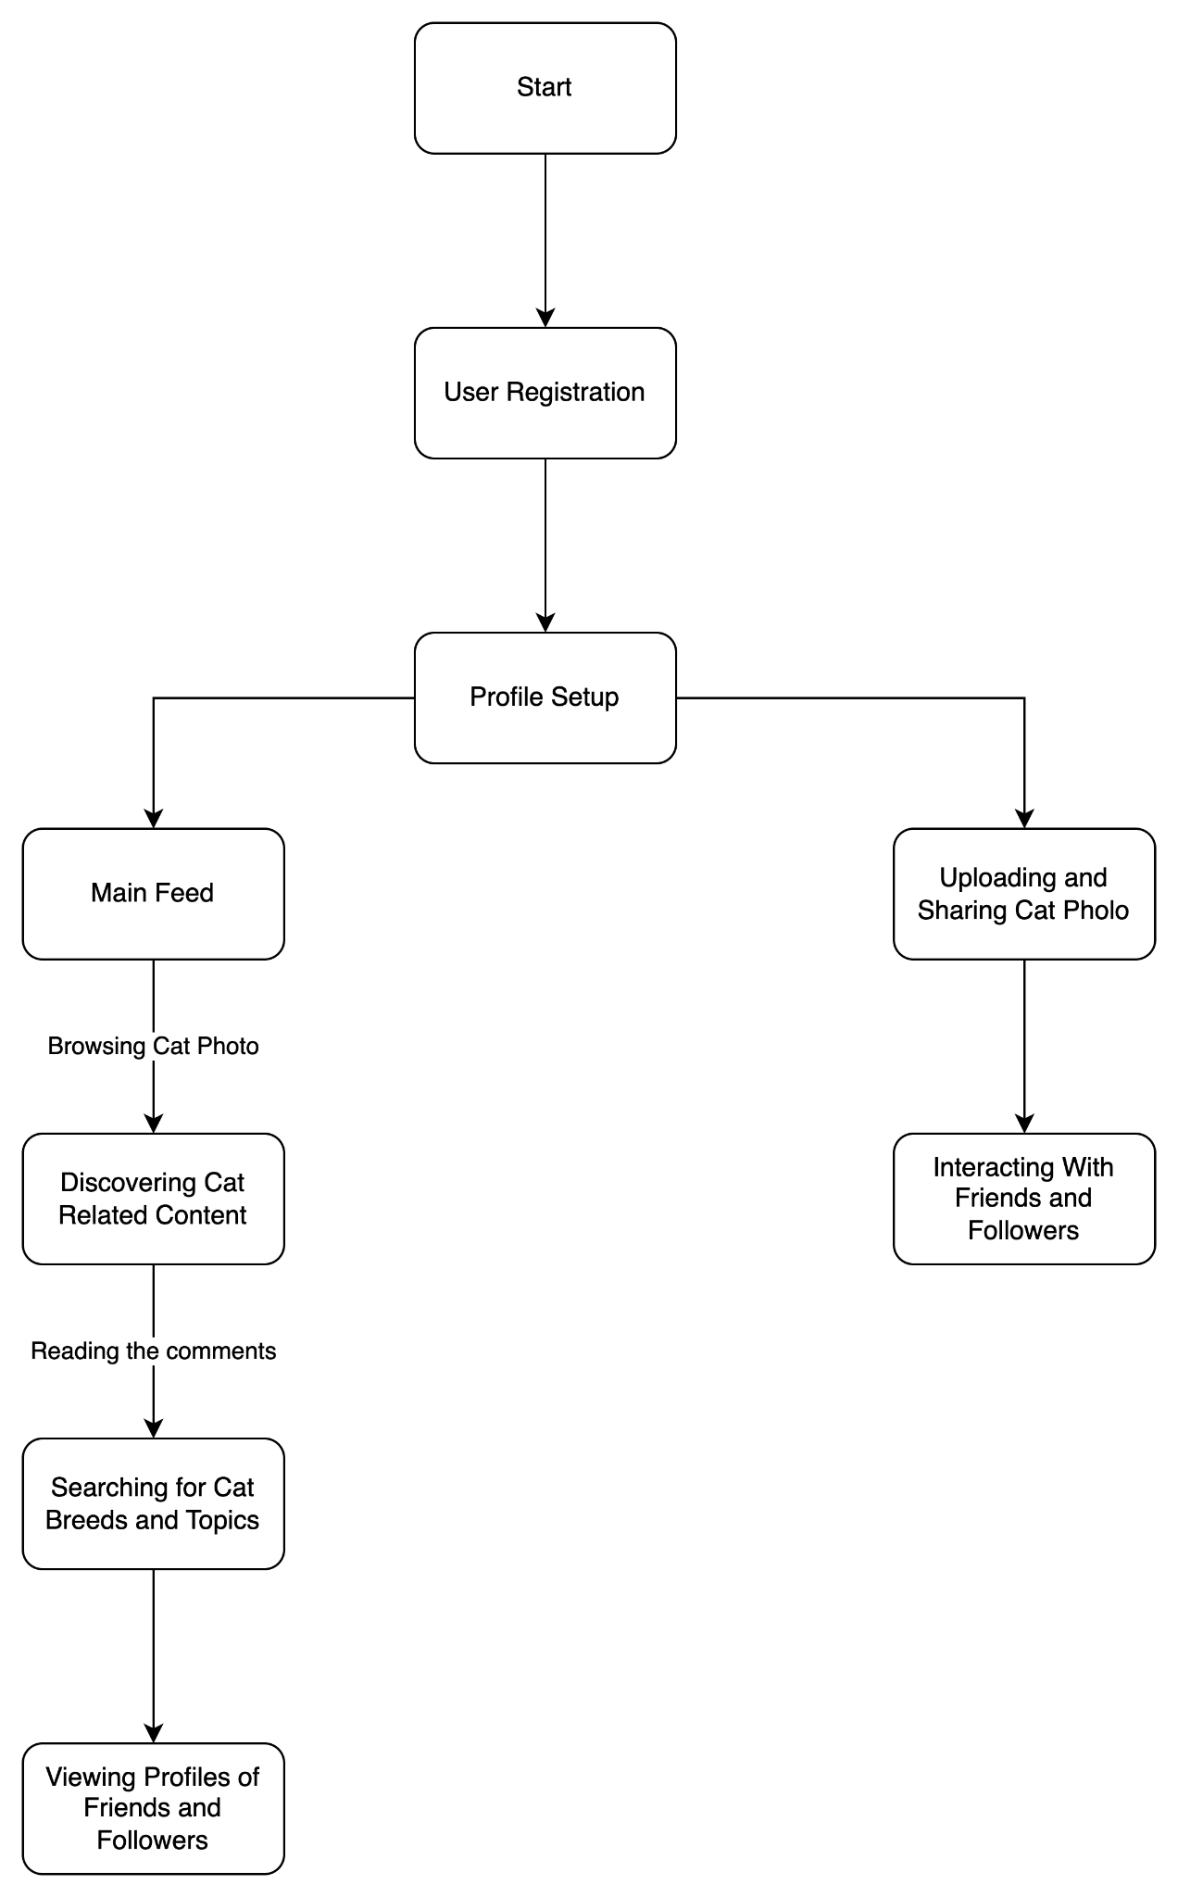

**Decision Table for User Registration**

| **Conditions** | T1 | T2 | T3 | T4 |
| --- | --- | --- | --- | --- |
| **The user is not registered** | 1 | 0 | 0 | 0 |
| **The user is already registered** | 0 | 1 | 0 | 0 |
| **Invalid Username** | 0 | 0 | 1 | 0 |
| **Successful Registration** | Not Pass | Pass | Not Pass | Not Pass |